GENAI HANDSON

Name: Ananya Reddy Gandlaparthi
SRN: PES2UG23CS064
Section: A

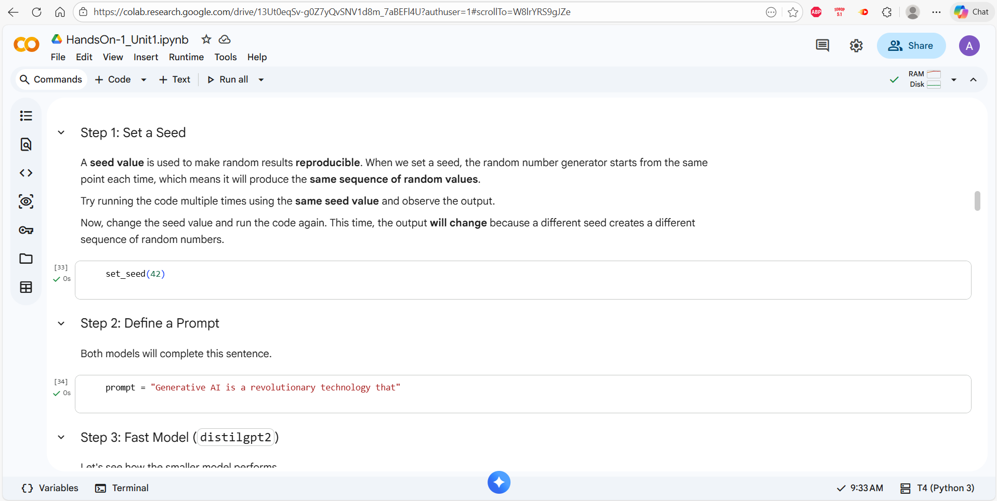
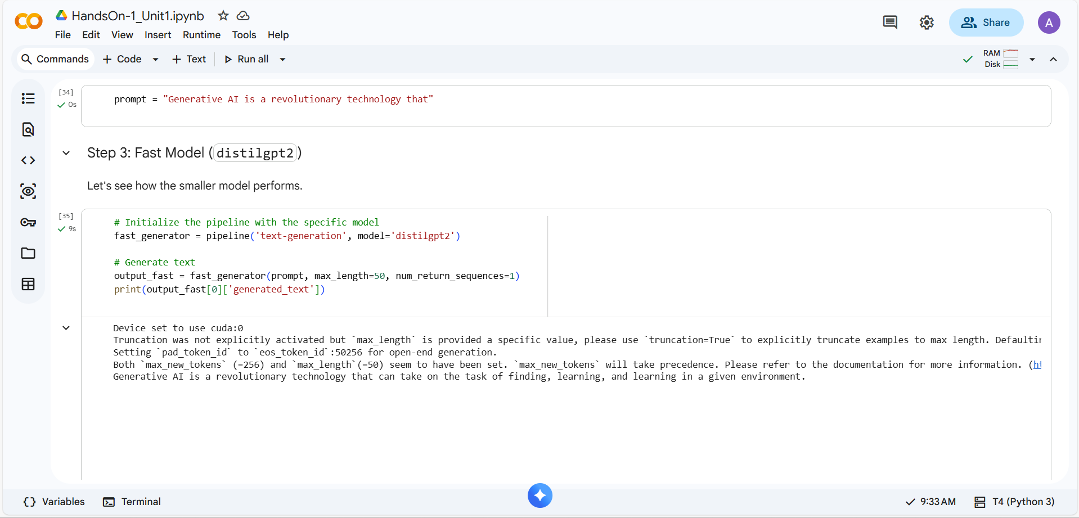
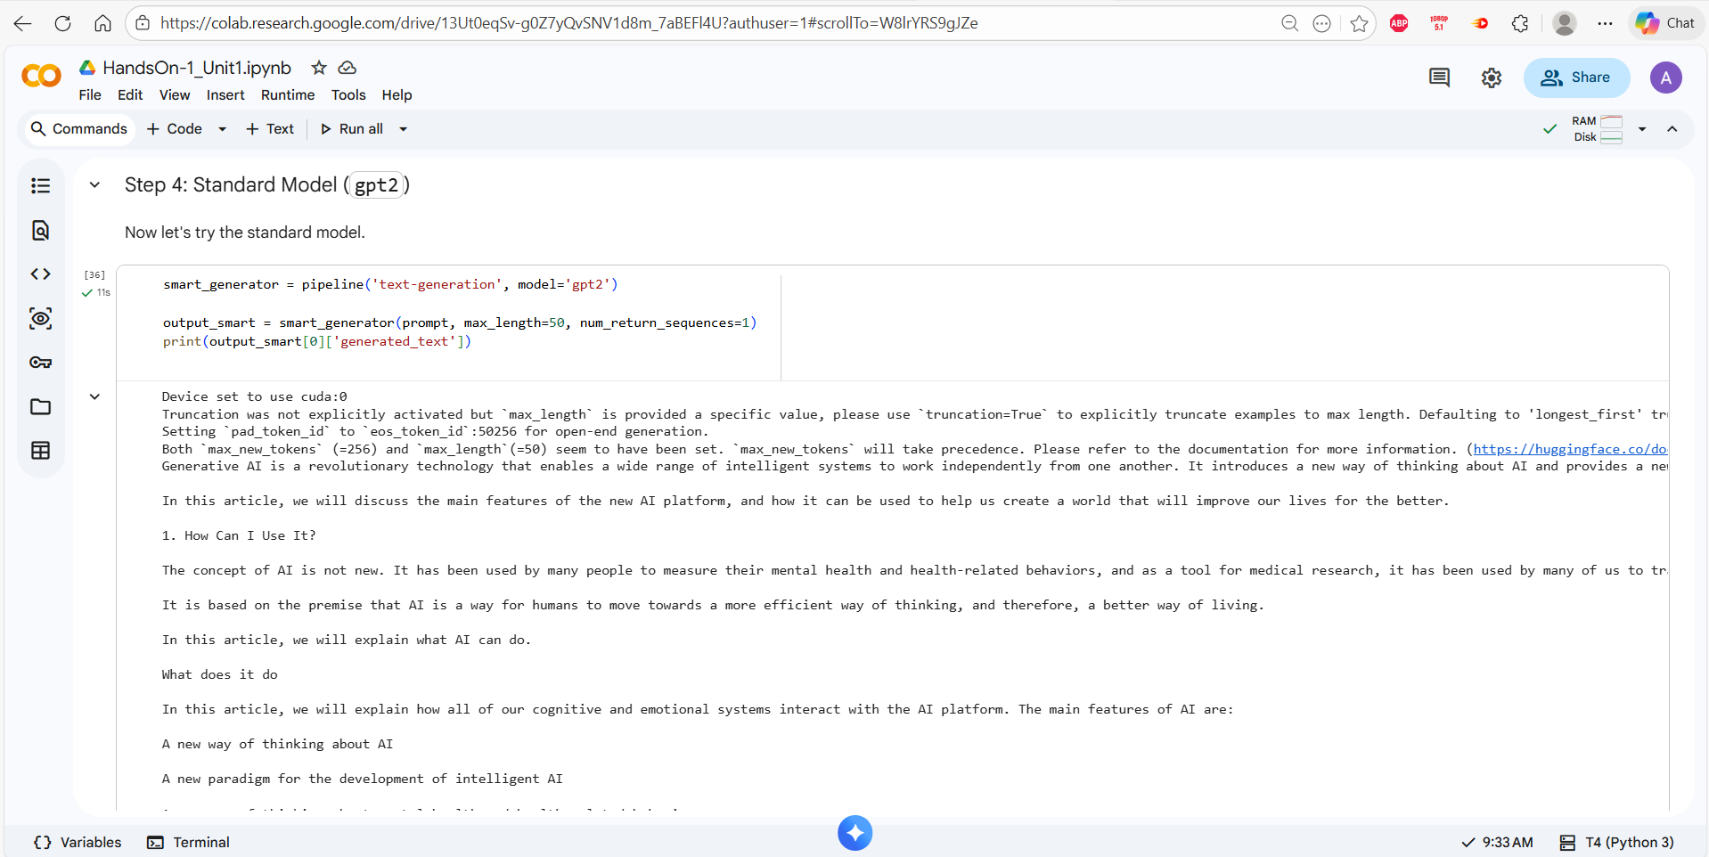
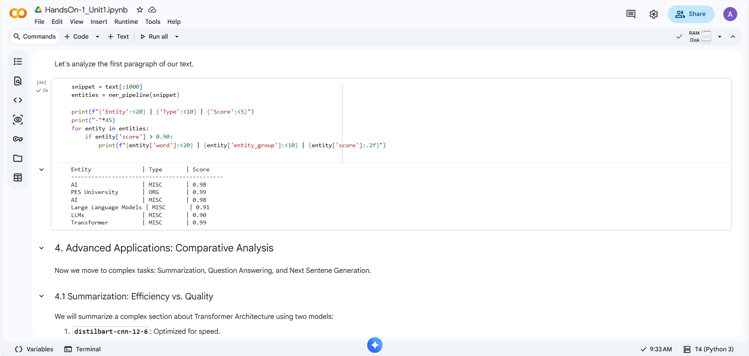
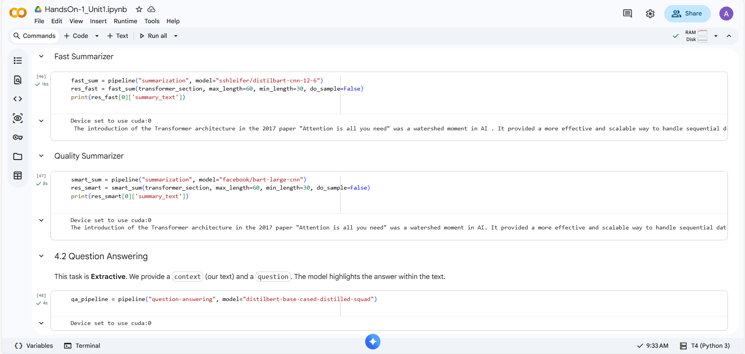
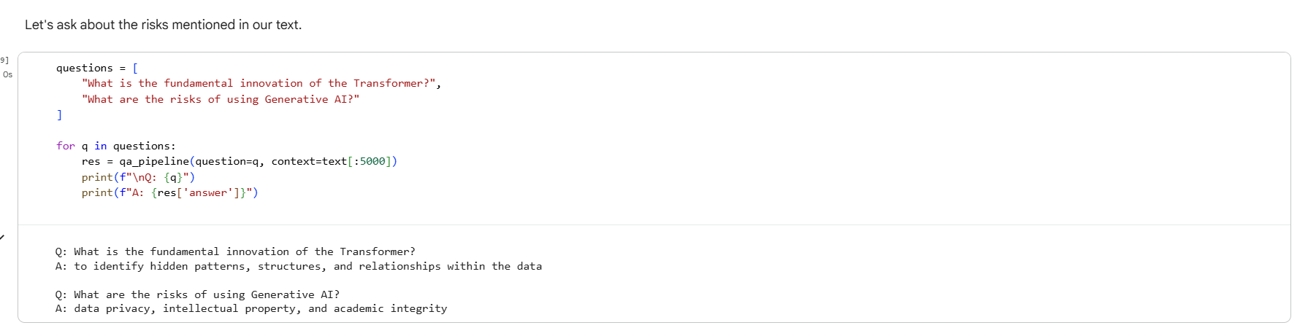
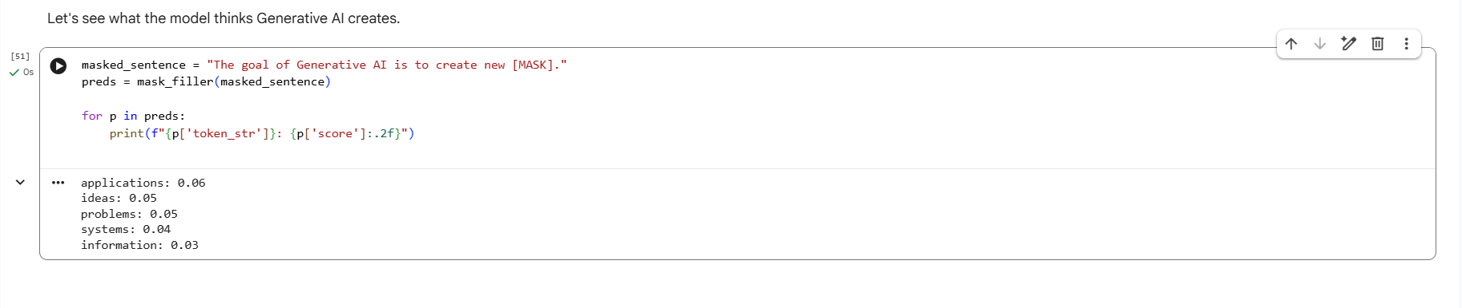

Seed: 50
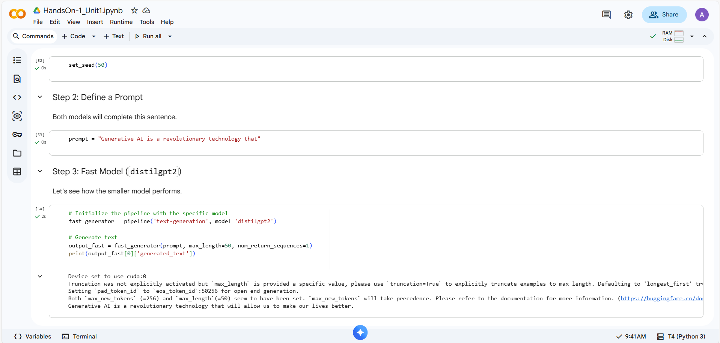

The distilgpt2 model, which is smaller and faster, generated a short, simple sentence. It was quick and gave a basic answer, but the output was limited. GPT2 model, which is bigger and smarter, generated much longer text with more details about AI benefits. It stayed more on topic and provided more information. The seed value of 42 made sure that both runs produced the same output each time.
Using the same seed value of 42 gave me the same generated text every time I ran the code, but when I changed the seed to 50 I got a different output. Bigger models like gpt2 and bart-large produce much better quality outputs than smaller models like distilgpt2 and distilbart, but they are slower and require more computing power.

